Stroop Effect Analysis

Background Information

In a Stroop task, participants are presented with a list of words, with each word displayed in a color of ink. The participant’s task is to say out loud the color of the ink in which the word is printed. The task has two conditions: a congruent words condition, and an incongruent words condition. In the congruent words condition, the words being displayed are color words whose names match the colors in which they are printed: for example RED, BLUE. In the incongruent words condition, the words displayed are color words whose names do not match the colors in which they are printed: for example PURPLE , ORANGE. In each case, we measure the time it takes to name the ink colors in equally-sized lists. Each participant will go through and record a time from each condition.

Questions For Investigation

1.What is our independent variable? What is our dependent variable?

Independent Variable: Congruent words and Incongruent words.

Dependent Variable: Time it takes to name the ink colors in equally-sized lists of congruent and incongruent words.

2. What is an appropriate set of hypotheses for this task? What kind of statistical test do you expect to perform? Justify your choices.

Hypotheses for stroop effect:

Null hypotheses: The time it takes to name the incongruent words have no effect or takes lesser time than the time it takes to name the congruent words.

H0  = μincongruent ≤ μcongruent

μincongruent is population mean of incongruent values and μcongruent is population mean of congruent values.

Alternative hypotheses: The time it takes to name the incongruent words takes more than the time it takes to name the congruent words.

HA  = μincongruent > μcongruent

Dependent t-test for paired samples is used due to two conditions are within subject designs. I have chosen t-test instead of z-test because the sample size is small as well as we do not know population parameters. Based on hypotheses one tailed test in positive direction is performed.

3. Report some descriptive statistics regarding this dataset. Include at least one measure of central tendency and at least one measure of variability.

Descriptive statistics is computed in python which includes mean, median and standard deviation, IQR.

Code:

# import pandas and numpy

import matplotlib.pyplot as plt

import pandas as pd

import numpy as np

import seaborn as sns

sns.set()

#read data from csv

stroopData = pd.read_csv("stroopeffect.csv")

print(stroopData)

Output:

Congruent Incongruent

0 12.079 19.278

1 16.791 18.741

2 9.564 21.214

3 8.630 15.687

4 14.669 22.803

5 12.238 20.878

6 14.692 24.572

7 8.987 17.394

8 9.401 20.762

9 14.480 26.282

10 22.328 24.524

11 15.298 18.644

12 15.073 17.510

13 16.929 20.330

14 18.200 35.255

15 12.130 22.158

16 18.495 25.139

17 10.639 20.429

18 11.344 17.425

19 12.369 34.288

20 12.944 23.894

21 14.233 17.960

22 19.710 22.058

23 16.004 21.157

# Descriptive statistics

stroopData.describe()

|  | **Congruent** | **Incongruent** |
| --- | --- | --- |
| **count** | 24.000000 | 24.000000 |
| **mean** | 14.051125 | 22.015917 |
| **std** | 3.559358 | 4.797057 |
| **min** | 8.630000 | 15.687000 |
| **25%** | 11.895250 | 18.716750 |
| **50%** | 14.356500 | 21.017500 |
| **75%** | 16.200750 | 24.051500 |
| **max** | 22.328000 | 35.255000 |

Mean and median represents the measure of central tendency. Range, standard deviation and IQR represents the measure of variability.

The mean and median for incongruent values is more than the congruent values so we can say that the time taken to name the ink colors of incongruent words is more that the congruent words. The range for incongruent words is 19.568 and for congruent words is 13.698.

4. Provide one or two visualizations that show the distribution of the sample data. Write one or two sentences noting what you observe about the plot or plots.

Using distplot() we can observe the univariate distribution in the dataset. Boxplot and histogram are as follows:

Code:

# Distplot for Incongruent words

sns.distplot(stroopData['Incongruent'])

plt.show()

Output:

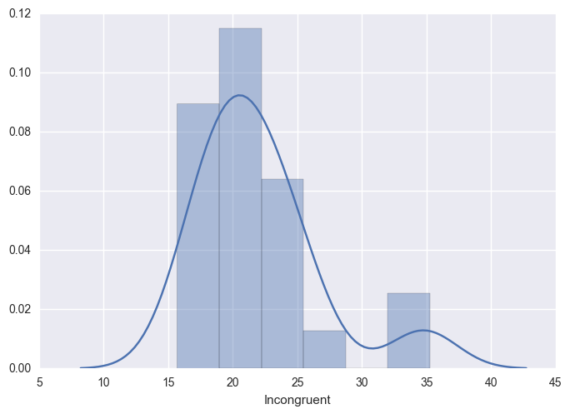

Code:

#Distplot for congruent words

sns.distplot(stroopData['Congruent'])

plt.show()

Output:

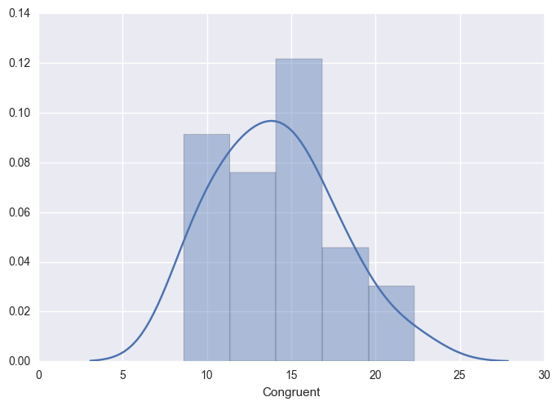

Code:

#Boxplot for both the conditions

df = pd.DataFrame(stroopData, columns=['Congruent', 'Incongruent'])

df.plot.box()

plt.show()

Output:

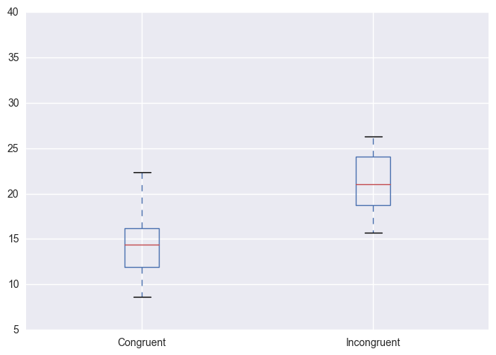

From the above plots, median for incongruent is higher than the congruent values. The distribution for congruent values is normal where as for incongruent the distribution of values are slightly narrow.

5. Now, perform the statistical test and report your results. What is your confidence level and your critical statistic value? Do you reject the null hypothesis or fail to reject it? Come to a conclusion in terms of the experiment task. Did the results match up with your expectations?

Calculating the confidence interval for 95%, one-tailed, df = 23 and ∝ = 0.05

Code:

#Creating a new column Difference to compute statistics

df['Difference'] = df['Incongruent'] - df['Congruent']

print df

Output:

Congruent Incongruent Difference

0 12.079 19.278 7.199

1 16.791 18.741 1.950

2 9.564 21.214 11.650

3 8.630 15.687 7.057

4 14.669 22.803 8.134

5 12.238 20.878 8.640

6 14.692 24.572 9.880

7 8.987 17.394 8.407

8 9.401 20.762 11.361

9 14.480 26.282 11.802

10 22.328 24.524 2.196

11 15.298 18.644 3.346

12 15.073 17.510 2.437

13 16.929 20.330 3.401

14 18.200 35.255 17.055

15 12.130 22.158 10.028

16 18.495 25.139 6.644

17 10.639 20.429 9.790

18 11.344 17.425 6.081

19 12.369 34.288 21.919

20 12.944 23.894 10.950

21 14.233 17.960 3.727

22 19.710 22.058 2.348

23 16.004 21.157 5.153

Code:

# Calculating mean and standard deviation for Difference Column

print df['Difference'].mean()

print df['Difference'].std()

Output:

7.96479166667

4.86482691036

Degree of freedom : 23

Standard error : std/sqrt(n) = 4.864/4.899 = 0.993

t-statistic : Difference mean/standard error = 7.965/0.993 = 8.021

tcritical : 1.714

Margin of error: tcritical * standard error = 1.714 * 0.993 = 1.702

Correlation = tstat2 / tstat2 + df = 64.336/87.336 = 0.736

p-value: Based on the graphpad calculator,

The result is for t=8.021   DF=23 The two-tailed P value is less than 0.0001   
By conventional criteria, this difference is considered to be extremely statistically significant.

We reject the null hypotheses because 8.021 is in the critical region as well as the p-value is less than the ∝ level and is statistically different.

Based on the experiment task we reject the null hypotheses and accept the alternative hypotheses that is we take more time to name the incongruent words than the congruent words. The results matched up with my expectations.

6. Optional: What do you think is responsible for the effects observed? Can you think of an alternative or similar task that would result in a similar effect? Some research about the problem will be helpful for thinking about these two questions!

Initially as we start reading we learn the meaning of the words and it becomes a practice. Due to this practice we feel confused to read the congruent words so it takes more time to process them in our brain. I think the similar task that would result in a similar effect is to color only first and last letter of each word.

References:

<https://en.wikipedia.org/wiki/Stroop_effect>

<https://researchbasics.education.uconn.edu/confidence-intervals-and-levels/>

<https://seaborn.pydata.org/tutorial/distributions.html#distribution-tutorial>

<https://d2l.deakin.edu.au/d2l/eP/presentations/presentation_preview_popup.d2l?presId=67655>